Basic Status
Device Information
Firmware Version:0.6.0 0.4 v0005.0 Build 130217 Rel.62075n
Hardware Version:TD-W8968 v1 00000000
System up time:27 day(s) 05:06:29

DSL
Line Status:Connected
DSL Modulation Type:ADSL_2plus
Annex Type:Annex A/I/J/L/M

 | Upstream | Downstream
Current Rate (Kbps) | 1020 | 8192
Max Rate (Kbps) | 1076 | 14608
SNR Margin (dB) | 7.4 | 11
Line Attenuation (dB) | 13.9 | 29
Errors (Pkts) | 0 | 0

WAN

Name | Connection Type | VPI/VCI | IP/Mask | Gateway | DNS | Status
pppoa_0_38_0_d | PPPoA | 0/38 | 92.18.44.9 /32 | 92.18.32.1 | 62.24.134.5 78.151.235.4 | Connected

IPv6 WAN

Name | Connection Type | VPI/VCI | IPv6 Address/Prefix Length | Gateway | DNSv6 | Status

LAN

MAC Address:A0:F3:C1:4F:D8:AC
IP Address:192.168.1.1
Subnet Mask:255.255.255.0
DHCP:Enabled

IPv6 LAN

IPv6 Address:N/A
Prefix Length:64
Autoconfiguration Type:RADVD

Wireless

Status:Enabled
SSID:Shapwick2
Channel:Auto(Channel 1)
Channel Width:Auto
Mode:11bgn mixed
Encryption:WPA-PSK/WPA2-PSK
MAC Address:A0:F3:C1:4F:D8:AC
Max Tx Rate:300Mbps
WDS Status:Disabled

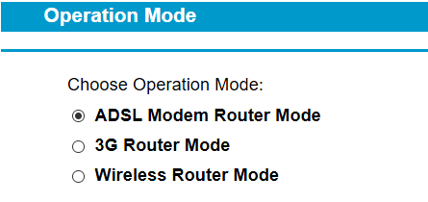
Operation Mode
Choose Operation Mode:
ADSL Modem Router Mode --this one
3G Router Mode
Wireless Router Mode

